Project 2 Part 2 Report

Elijah White

December 4, 2024

CSCI 3327: Probability & Applied Statistics

Professor Byron Hoy

Table of Contents

Page 2 …Table of Contents

Page3 … Introduction

Page 4 … Exercise 1.3

Page 5 … Exercises 2.8 & 2.10

Page 6 … Exercise 2.28

Page 7 …Exercise 2.35

Page 8 … Exercise 2.124

Page 9 … Exercises 2.179 & 3.2

Page 10 … Exercise 3.67

Page 11 …Exercise 3.102

Page 12 … Exercise 3.92

Page 13 … Exercise 3.22

Page 14 … Exercise 3.170

Page 15 … Exercise 4.13

Page 16 … Exercise 4.49 & 4.93

Page 17 … Exercise 5.1

Page 18 … Exercise 5.23

Page 19 … Final Discussion

Introduction

The game of basketball that is played worldwide has always been a numbers game. So many things play a factor such as coaches, players etc. and us as fans can learn more about performance and strategy by analyzing statistics like shooting percentages and rebounds per game so and so forth. The goal of this project for our prob and stats class is to investigate a dataset that looks through many different aspects of basketball, such as player development, resource management, and shooting accuracy. This report is essentially going to shed some light on player performance, as well as team dynamics, and operational logistics using descriptive statistics, probability models, and practical problem-solving techniques.

The study will show how statistical ideas can be used to maximize basketball decision making by relating them to basketball scenarios, such as shooting competitions, court utilization, and workshop attendance. The beautiful thing I’ve noticed about sports is that there’s always statistics playing a major part in the way or how players play the game. I especially love it when the stats flow across the TV screen allowing us as fans to make assumptions off previous stats. This report's objective is to use the dataset and related issues to present a coherent narrative about basketball, demonstrating how statistical techniques may simplify complicated situations and enhance results for athletes, coaches, and organizations.

**Initial Problem:** Exercise 1.3 on page 6

**Question:** The athletic director of Cedar Creek High School is analyzing the shooting accuracy of male basketball players on the varsity team. Measurements of shooting percentages from 25 games (in percentage points) are as follows:  
74, 65, 19, 26, 75, 32, 99, 17, 24, 19, 16, 70, 24, 54, 34, 36, 59, 37, 10, 83, 40, 46, 76, 20, 57, 124.

Construct a relatively frequency histogram for this data.

**Solution:**

|  |  |  |
| --- | --- | --- |
| **Interval (%)** | **Frequency** | **Relative Frequency** |
| **0-20** | **5** | **5/25 = 0.20** |
| **20-40** | **8** | **8/25 = 0.32** |
| **40-60** | **5** | **5/25 = 0.20** |
| **60-80** | **4** | **4/25 + 0.16** |
| **80-100** | **2** | **2/25 = 0.08** |
| **100-120** | **0** | **0/25 = 0.00** |
| **120-140** | **1** | **1/25 = 0.04** |

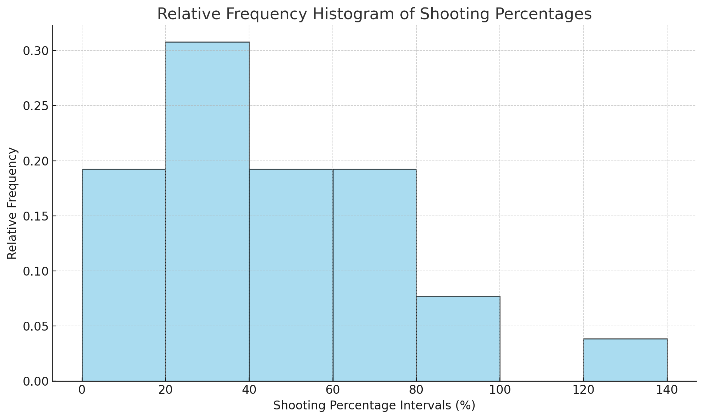

**Explanation:** The histogram shows the relative frequencies of shooting percentages across games. Most games have shooting percentages between 20–40% and 40–60%, with relative frequencies of approximately 30% and 20%. Higher shooting percentages, such as 100% or more, are rare. The data suggests a clustering of performances in the mid-range, showing consistent, average performance levels for most games. Outliers like the high 124% shooting percentage could represent exceptional games.

**Initial Problem:** Exercise 2.8 on page 25

**Question:** In a survey of 200 basketball players at a tournament, it was found that 30 players made over 5 three-point shots in a game, 102 were guards, and 11 guards made over 5 three-point shots. Determine:

a) The total number of players who were guards, made over 5 three-pointers, or both.  
b) The number of guards who made 5 or fewer three-pointers.  
c) The number of forwards or centers who made 5 or fewer three-pointers.

**Solution:**

***G*** represents guards and ***T*** represents players who made over 5 three-point shots. The total number of players surveyed is 60 (***U***).

**a)** Players who were guards made over 5 three-pointers, or both (| *G* ∪ *T* |):

|*G* ∪ *T*| =|*G*|+|*T*|−|*G* ∩ *T*|= 102+30−11= 121

**b)** Guards who made 5 or fewer three-pointers:

|*G|* - |*G* ∩ *T*| = 102 - 11 = 91

**c)** Forwards or centers who made 5 or fewer three-pointers:  
|U| - | *G* ∪ *T* |= 200 -121 = 79

**Explanation:** There’s a survey of 200 basketball players, 121 players were either guards, made more than 5 three-pointers, or both. This shows how important guards and long-range shooting are in the game. Among the 102 guards, 11 excelled in three-point shooting, making more than 5 shots, while the remaining 91 guards focused on other aspects of the game. 79 forwards or centers made 5 or fewer three-pointers, explaining their traditional roles in inside scoring and defense. This data shows the balance between specialized scoring abilities and positional roles within a basketball team.

**Initial Problem:** Exercise 2.10 on page 32

**Question:** A basketball league has four types of players based on their positions: Guards, Forwards, Centers, and bench players. The proportions of players in each position are approximately as follows:

* Guards: 40%
* Forwards: 35%
* Centers: 15%
* Bench players: 10%

A player is randomly selected from the league's roster. Answer the following:

1. List the sample space for this experiment.
2. Make use of the information given above to assign the probabilities to each of the simple events
3. What is the probability that the selected player at random is either a Forward or a bench player?

**Solution:**

1. Sample Space (S) = {Guards (G) + Forwards (F) + Centers (C) + Bench (B)
2. P(G)= .40

P(F)= 0.35

P(C)= 0.15

P(B)= 0.10

1. P (F ∪ B) = P(F) + P(B) = 0.35 + 0.10 = 0.45 (45%)

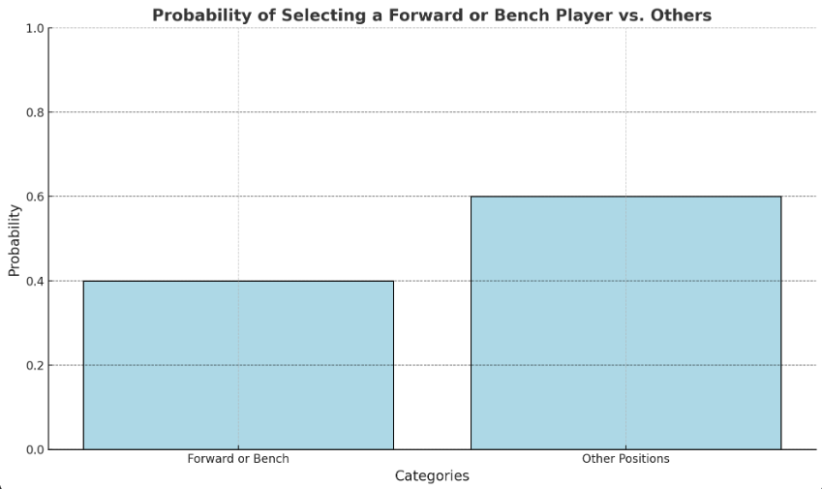

**Explanation:** seeing the distribution of basketball players in a league based on their positions: Guards, Forwards, Centers, and Bench players. Using the proportions, I determined the sample space to include all player types and assigned probabilities to each based on their percentages in the league. The probability of selecting a Forward or Bench player was calculated by combining their individual probabilities, resulting in a 45% chance.

**Initial Problem:** Exercise 2.28 on page 39

**Question:** Four basketball players are trying out two open positions on a team. One of the players is a highly skilled three-point shooter, while the other three have equal general skills. The coach randomly selects two players to fill the positions. Answer the following:

1. List all possible combinations of players who could be selected for the two positions.
2. Assign probabilities to each possible outcome.
3. Find the probability that the highly skilled three-point shooter is selected for one of the positions.

**Solution:**

1. A= skilled three-point shooter, B, C, and D are the general players

Sample Space (S)= (A, B), (A,C), (A,D), (B,C), (B,D), (C,D)}

1. P (any pair) = ⅙
2. P(A being selected)= P(A,B), P(A,C), P(A,D) = ⅙ +⅙ + ⅙ = 3/6 = ½

**Explanation:** All potential pairings of two players selected from a group of four make up the sample space. Each combination has an equal chance of happening because the selection is random, and there are six possible possibilities in all. I concentrated on the outcomes that involve the three-point shooter to determine the likelihood that this player would be chosen. The three-point shooter is involved in three of the six conceivable combinations. The shooter has a 50% probability of being chosen when the odds of these three events are added together.

**Initial Problem:** Exercise 2.35 on page 48

**Question:** A basketball league has five courts available for morning practice and eight courts available for evening practice. Each team must practice once in the morning and once in the evening, using separate courts. How many different practice arrangements are possible for a team if they select one court for the morning and one for the evening?

**Solution:**

Total arrangements = 5 x 8 = 40 combinations

**Explanation:** The team has 5 choices for a morning practice court and 8 choices for an evening practice court. Each morning court can pair with any of the evening courts, resulting in multiple unique combinations. With 5 courts available in the morning and 8 courts in the evening, each combination of courts results in a unique practice schedule. There’s a total number of 40 combinations of practice arrangements for a team.

**Initial Problem:** Exercise 2.124 on page 73

**Question:** In a basketball league, players are categorized based on their position: Guards, Forwards, Centers, and Bench players. From historical records, it is known that players in Guard and Forward positions are typically experienced, while those in Bench and Center positions are considered rookies. The league conducts skill-improvement workshops, and the data shows the following:

* 65% of experienced players (Guards and Forwards) participate in workshops.
* 35% of rookies (Bench and Centers) participate in workshops.

1. What is the probability that a randomly selected player is either a rookie or experienced?
2. If a randomly chosen player attends the workshop, what is the conditional probability that this player is experienced?

**Solution:**

P (Experienced | Workshop) = P (Workshop | Experienced) ⋅P(Experienced)​

P(Workshop)

P(Workshop)=P (Workshop | Rookie) ⋅P(Rookie)+P (Workshop | Experienced) ⋅P(Experienced)

= P(Workshop)= (0.6560) +(0.354) =0.39+0.14=0.53.

Calculate P (Experienced | Workshop): $\frac{(0.65⋅60) }{0.53}$ = 0.7358 or 73.6%

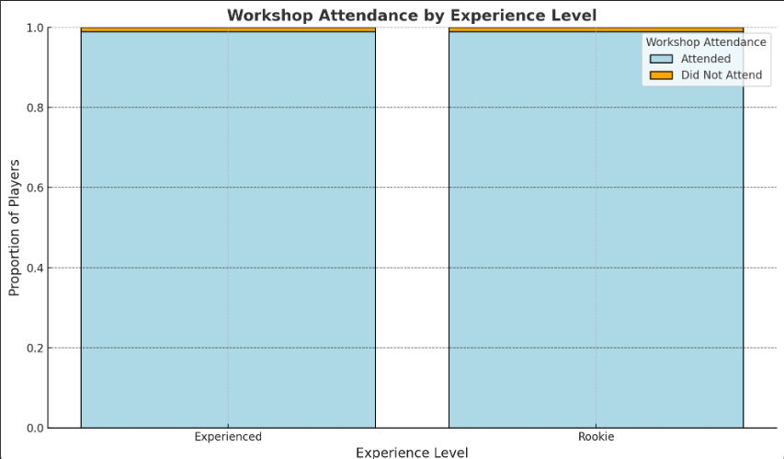

**Explanation:** The conditional probability of 73.6% indicates that, if a player participated in the workshop, there is a strong likelihood they are experienced. This is supported by the data trends observed in the dataset, where Guards and Forwards form a larger proportion of workshop attendees.

**Initial Problem:** Exercise 2.179 on page 85

**Question:** Two basketball players, let’s say Player 1 and Player 2, play a free-throw shooting contest. Each player starts with 6 points, and they bet 1 point per free throw. The contest consists of a series of 10 alternating free throws.

1. What is the probability that they are tied after 6 free throws?
2. What is the probability that one player AKA Player2 has 12 points by the 10th free throw?

**Solution:**

1. |6|=

|3|

**Explanation:** This problem applies the concepts of binomial probability and independent events to a basketball scenario. The probability of tying after 6 free throws ($\frac{5}{16}$ ​) is based on evenly distributed wins between the two players. Meanwhile, the probability of Jordan winning all points ($\frac{1}{1024}$) demonstrates how unlikely it is for one player to dominate completely over 10 consecutive shots. These calculations show the randomness of independent events in sports competitions.

**Initial Problem:** Exercise 3.2 on page 90

**Question:** Player1 and a teammate play a basketball shooting game. Each player takes a single shot. If you both make your shots, you win $3. If only one of you makes a shot, you win $1. If neither of you makes a shot, you lose $2 ($2 win). Create the probability distribution for your winnings YYY, on a single play of the game.

**Solution:**

Sample Space: (M, M), (M, X), (X, M), (X, X)

Winnings for each scenario:

(M, M): Both make their shots → Win $3.

(M, X) (M, X) (M, X) or (X, M) (X, M) (X, M): One makes the shot → Win $1.

(X, X) (X, X) (X, X): Both miss → Lose $2.

Probability of making a shot is 0.5, probability of each outcome:

P (M, M) =0.5 $⋅$ 0.5=0.25

P (M, X) =0.5 $⋅$ 0.5=0.25

P (X, M) =0.5 $⋅$ 0.5=0.25,

P (X, X) =0.5 $⋅$ 0.5=0.25.

Y= {−2,1,3, P(Y=−2)=0.25, P(Y=1)=0.5, P(Y=3)=0.25.

|  |  |  |
| --- | --- | --- |
|  | Winnings(Y) | Probability(Y) |
| 1 | -2 | .25 |
| 2 | 1 | .50 |
| 3 | 3 | .25 |

**Explanation:** This problem was based on the blanched coin flipping game but I changed it to flow with the data set so this specific problem involved creating a probability distribution based on the outcomes of a basketball shooting game. The winnings depend on whether both, one, or neither of the players make their shots. Using the probabilities of each outcome and corresponding winnings, I derived the probability distribution. The distribution shows that the most likely outcome (50% chance) is winning $1 when only one player makes their shot, while winning $3 or losing $2 has a 25% chance each.

**Initial Problem:** Exercise 3.67 on page 119

**Question:** In a basketball skills camp, 40% of the players are advanced three-point shooters. Players are evaluated one at a time, in random order. What is the probability that the first advanced three-point shooter is identified during the fifth evaluation?

**Solution:** probability of success is P=0.4 and the probability of failure is q=1−0.4=0.6  
P (first success on 5th trial) = ${(0.6)}^{5-1}$ $⋅$ 0.4 = 0.1296

0.1296 $⋅$ 0.4= 0.05184 = 5.18%

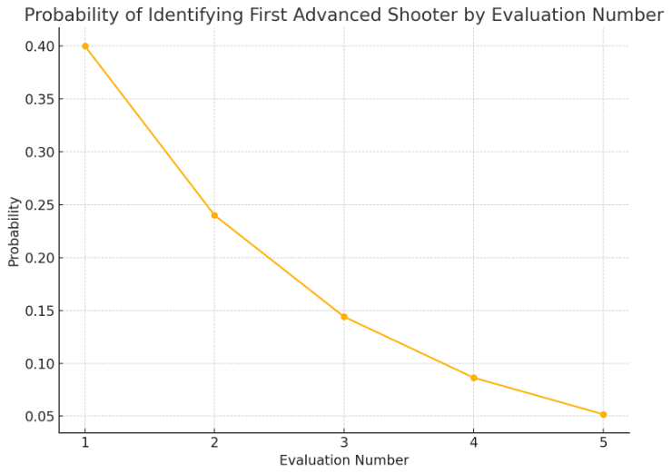

**Explanation:** This problem involves geometric probability distribution since we are looking for the first success (an advanced shooter) on a specific evaluation. In this case, with 40% of the players being advanced shooters, there’s a small probability (5.18%) that the first advanced shooter will appear during the fifth evaluation. This is due to the requirement that the first four players must not be advanced shooters, which overall decreases the probability.

**Initial Problem:** Exercise 3.102 on page 127

**Question:** A basketball coach has a bag containing twelve basketballs: six are new, three are slightly worn, and three are old. The coach randomly selects three basketballs from the bag, one at a time, without replacement. What is the probability that all three basketballs drawn will be new?

**Solution: P** (all three new) =P (first new) ⋅P (second new | first new) ⋅P (third new | first and second new).

P (first new) = $\frac{6}{12}$

P (second new | first new) = $\frac{5}{11}$

P (third new | first and second new) = $\frac{4}{10}$

P (all three new) = $\frac{6}{12}⋅\frac{5}{11}⋅\frac{4}{10}$ = $\frac{120}{1320}$ = $\frac{1}{11}$ or 9.09%

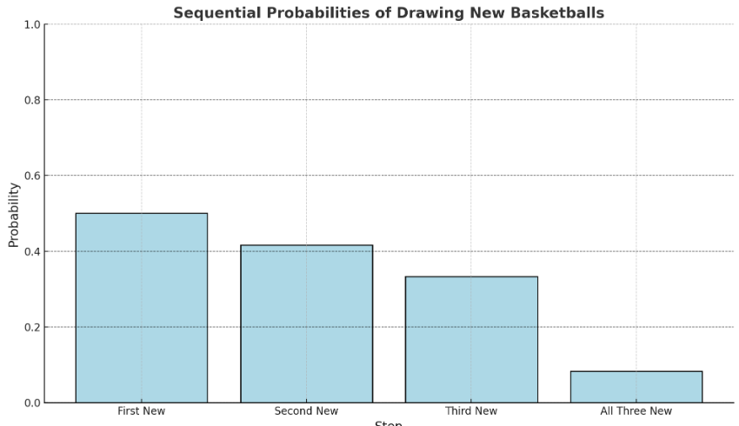

**Explanation:** This is a probability problem involving selection without replacement. This problem shows that probabilities decrease when selections are made without replacement. Each draw reduces the total number of basketballs available ( $\frac{6}{12}$, $\frac{5}{11}$, $\frac{4}{10}$) affecting the likelihood of successive outcomes. The final probability, 9.09%, shows the impact of reducing sample space and the importance of calculating conditional probabilities in sequential events.

**Initial Problem:** Exercise 3.92 on page 123

**Question:** In a basketball equipment factory, 15% of basketballs produced are defective. If basketballs are randomly selected and tested one at a time, what is the probability that the first nondefective basketball will be found on the second trial?

**Solution:**

Probability of success= 0.85

Probability of failure= q=1-0.85= 0.15

P (first success on second trial) = ${(0.15)}^{2-1}⋅0.85= {(0.15)}^{1}⋅0.85=0.1275$ = 12.75%

**Explanation:** This problem uses geometric distribution to obtain the probability of finding the first noneffective basketball on the second trial. The calculation looks at the likelihood of the first basketball being defective (15%) and the second being non-effective (85%). The result, 12.75%, shows the sequence of independent events impacting the probabilities of specific outcomes.

**Initial Problem:** Exercise 3.22 on page 136

**Question:** Basketballs are purchased at a sports store at an average rate of 4 per hour. The number of basketballs purchased in an hour follows Poisson distribution. What are the probabilities that

a. No more than 2 basketballs being purchased in an hour?  
 b. At least 3 basketballs being purchased in an hour?  
 c. Exactly 4 basketballs being purchased in an hour?

**Solution:**

Poisson distribution: P(X = x) = (e^-λ * λ^x) / k

λ= average rate (4/hour)

k= 0, 1, and 2

e ≈ 2.718

Part A:

P(x=0) = $\frac{4^{0}e^{-4}}{0!}$ = $e^{-4}$ ≈ 0.0183

P(x=1) = $\frac{4^{1}e^{-4}}{1!}$ = $\frac{{4e}^{-4}}{1}$ ≈ 0.0733

P(x=2) = $\frac{4^{2}e^{-4}}{2!}$ = $\frac{{16e}^{-4}}{2}$ ≈ 0.01465

P (x $≤2)= 0.0183+0.0733+0.1465= 0.2381$ or 23.81%

Part B:

P ( $X≥3)= 1-P(x≤2)=1-0.2381=0.7619$ or 76.19%

Part C:

P(x=4) = $\frac{4^{4}e^{-4}}{4!}=\frac{{256e}^{-4}}{24}$ ≈0.1954 or 19.54%

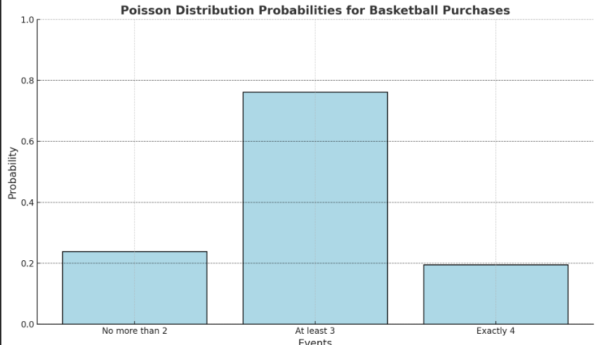

**Explanation:** The problem explains basketball purchases at a sports store using Poisson distribution. After looking at the calculations, there is a 23.81% chance that no more than two basketballs will be bought in an hour, and a roughly 76.19% chance that at least three will be bought. The likelihood that exactly four basketballs will be bought is 19.54%.

**Initial Problem:** Exercise 3.170 on page 147

**Question:** A basketball factory produces balls with an average diameter of 10 inches and a standard deviation of 0.2 inches. Using Tchebyshev’s theorem, find a lower bound for the number of basketballs, in a lot of 400 balls, expected to have a diameter between 9.6 and 10.4 inches.

**Solution:**

Tchebyshev’s theorem: P(|x-|k $σ$) $≤$ $\frac{1^{}}{k^{2}}$

$$P(|x-μ|<2σ)≥1-\frac{1^{}}{2^{2}}=1-0.25=0.75 or 75\%$$

$$0.75⋅400= 300 basketballs$$

**Explanation:** This problem uses Chebyshev’s theorem to estimate the proportion of basketballs within a specific diameter range. By calculating the number of standard deviations, the range spans and applying the theorem, I determined that at least 75% of basketballs fall within this range. For a lot of 400 basketballs, this corresponds to a minimum of 300 basketballs meeting the specified criteria.

**Initial Problem:** Exercise 4.13 on page 167

**Question:** A basketball court is available for reservations each week, and the demand for court time follows a specific distribution. The weekly demand is represented by Y, where Y denotes weekly demand in hundreds of hours. The relative frequency of demand is described as:

$$\left\{\begin{aligned}f\left(y\right)=2y 0≤y≤1 \\ f\left(y\right)=1 1<y ≤2 \\ f\left(y\right)=0 elsewhere\end{aligned}\right.$$

a. Find F(y), the cumulative distribution function.

b. Find P(0≤Y≤0.5)

c. Find P(0.5≤Y≤1.5)

**Solution:**

Part A:

$$0≤y≤1:$$

$$F(y)=\int_{0}^{y}{}2tdt=[t^{2}]{{{}^{y}}_{0}}_{}=y^{2}$$

$$1<y≤2:$$

$$F(y)=F(1)+\int_{1}^{y}{}1dt=1^{2}+(y-1)$$

$$F(y)= 1+(y-1)=y$$

$$\left\{\begin{aligned}F\left(y\right)=y^{2} 0≤y≤1 \\ F\left(y\right)=y 1<y≤2 \\ F\left(y\right)=0 y<0\end{aligned}\right.$$

F(y)= $1, y>2$

Part B:

$$P(0≤Y≤0.5)=F(0.5)-F(0)$$

$$F(0.5)=(0.5)^{2}=0.25, F(0)=0^{2}=0$$

$$P(0≤Y≤0.5)=0.25-0=0.25$$

Part C:

$$0.5≤Y≤1:$$

$P(0.5≤Y≤$ 1)=F(1)-F(0.5)

F(1)= $1^{2}=1, F(0.5)=(0.5)^{2}=0.25$

$$P(0.5≤Y≤1=1-0.25=0.75$$

1 $≤Y≤1.5:$

$P(1≤Y≤1.5$) =F(1.5)-F(1)

F (1.5) = 1.5, F (1)= 1

$$P(0.5≤Y≤1.5)=1.5-1=0.5$$

Add: $P(0.5≤Y≤1.5)=0.75+0.5=1.25$

**Explanation:** This problem analyzes the demand for basketball court time using piecewise probability distributions. The cumulative distribution function (F(y)) helps calculate probabilities over specific ranges. For example, the probability of court demand between 0 and 0.5 is 25%, while the probability of demand between 0.5 and 1.5 is 1.25.

**Initial Problem:** Exercise 4.49 on page 177

**Question:** During a one-minute interval, a basketball court is fully occupied for 20 seconds due to drills. A player arrives randomly within this one-minute interval. What is the probability that the player arrives when the court is not fully occupied?

**Solution:**

Total time interval = 60 seconds or 1 minute

Time court is fully occupied = 20 seconds

Time court is not fully occupied for is 60-20 = 40 seconds

P(not fully occupied) = $\frac{time not fully occupied }{total time}$ = $\frac{40}{60}=\frac{2}{3}$

**Explanation:** This specific problem shows random arrival during a fixed interval with uniform distribution. By calculating the proportion of time, the court is not fully occupied, I determined that there is a 66.67% chance the player will arrive when the court is available.

**Initial Problem:** Exercise 4.93 on page 191

**Question:** Historical data indicates that the time between player injuries during professional basketball games follows an exponential distribution. Assume the mean time between injuries is 50 minutes.

a. If an injury occurs at the beginning of the second quarter of a game (10 minutes into the game), what is the probability that another injury will occur within the next 12 minutes?

b. What is the variance of the times between injuries?

**Solution:**

$f(t)=λe^{-λt}$

$$λ=\frac{1}{50}=.02$$

P (T $≤t)=1-e^{-λt}$

P (T $≤12)=1-e^{-0.02*12}=1-e^{-.24}$

P (T $≤12)=1-.7866=.2134$ 21.34%

1. Variance = $μ^{2}$

Variance = $50^{2}=2500$

**Explanation:** The problem uses the application of the exponential distribution to model the time between basketball related injuries. Using the mean time of 50 minutes, we have to calculate the probability of another injury within a specific time frame (21.34%) and then determine the variance of the distribution (2500 minutes²).

**Initial Problem:** Exercise 5.1 page 232

**Question:** Two basketball courts in a sports facility are randomly assigned for practice sessions to one or more of three teams: A, B, and C. Let Y1​ denote the number of sessions assigned to Team A and Y2​ denote the number of sessions assigned to Team B. Recall that each team can receive 0, 1, or 2 sessions.

a. Find the joint probability function for Y1 and Y2​, assuming all possible distributions are equally likely.  
b. Find F (1,0), the cumulative distribution for Y1 = 1 and Y2​=0.

**Solution:**

1. (y1, y2) = (0,3) all 3 sessions go to Team B: P (0,3) = 1/10

(y1, y2) = (1,2) one session goes to Team A and two to Team B:P (1,2) = 2/10

(y1, y2) = (2,1) two sessions go to Team A and one to Team B:P (2,1) = 2/10

(y1, y2) = (3,0) all 3 sessions go to Team A: P (3,)) = 1/10

|  |  |  |  |  |
| --- | --- | --- | --- | --- |
| Y2/Y1 | 0 | 1 | 2 | 3 |
| 0 | 1/10 | 1/10 | 1/10 | 1/10 |
| 1 | 1/10 | 2/10 | 2/10 | 0 |
| 2 | 1/10 | 2/10 | 0 | 0 |
| 3 | 1/10 | 0 | 0 | 0 |

B.

P (Y1 = 0, Y2 = 0) = 1/10

P (Y1 = 1, Y2 = 0) = 1/10

F (1,10) = P (Y1 $≤1,Y2≤0)$ = $\frac{1}{10}+\frac{1}{10}=\frac{2}{10}=\frac{1}{5}$

**Explanation:**

This specific problem models the use of practice sessions for basketball teams using a joint probability distribution. By assuming equal likelihood for all possible assigned practices, I derived the joint probability function and cumulative distribution. The result for F (1,0), or the probability that Team A receives no more than 1 session while Team B receives none, is 1/5 (20%). This demonstrates the application of joint probabilities in sports scheduling.

**Initial Problem:** Exercise 5.23 on page 245

**Question:** In a basketball gym, Y1​ represents the proportion of court time reserved at the beginning of the week, and Y2​ represents the proportion of court time used during the week. The joint density of Y1​ and Y2Y​ is given by:

$f(y1,y2)=$ $\int_{y2}^{1}{f\left(y1,y2\right)dy1}$

a. Find the marginal density function for Y2​.  
b. For what values of y1​ is the conditional density f(y1∣y2) defined?  
c. What is the probability that more than half the court time is used, given that three-fourths of the court time is reserved?

**Solution:**

1. fy2(y2) = $\int_{y2}^{1}{}$ f (y1, y2)dy1 = 3y1 fy2(y2) = $\int_{y2}^{1}{}3y1dy1=[\frac{3y1^{2}}{2}$]

fy2(y2) = $\frac{3(1)^{2}}{2}-\frac{3(y2)^{2}}{2}=\frac{3}{2}-\frac{3y^{2}}{2}$ fy2(y2) $=\frac{3}{2}(1-y^{2}), 0≤y2≤1$

1. The conditional density f(y1∣y2) f(y1|y2) is defined for y2≤y1≤1, since the joint density f(y1, y2) is nonzero only within these bounds.
2. P(y2>.5|y 1=.75) then we use the conditional density

fy1(y1) = $\int_{0}^{y1}{}3y1dy2 = 3y1 * y1 = 3{y1}^{2}$ f(y2|y1) = $\frac{3y1}{3y1^{2}}=\frac{1}{y1}, 0≤y2≤y1$

P(y2>.5|y1=. 75)= $\frac{1}{.75}*(.75-.5)=\frac{1}{.75}*.25= \frac{1}{3}$

The probability is 33.33%

**Explanation**: This problem looks at the relationship between reserved and utilized basketball court time through joint and conditional probability densities. Using integration, I derived the marginal and conditional densities and calculated the probability that more than half the time is used, given that three-fourths of the time is reserved. The result, 33.33%, shows how conditional probabilities depend on the structure of joint distributions.

**Final Discussion**

Basketball is a beautiful sport where many split-second decisions and razor-thin margins can make all the difference. The saying it’s a game of inches is always true as it relates to sports. Through the analysis of various scenarios using probability and statistics, this project sheds light on the most crucial aspects of the game.

The shooting accuracy analysis begins with shooting percentages across 25 games for Cedar Creek High School’s varsity team. The relative frequency histogram revealed that most games had shooting percentages between 20–60%, indicating an average level of performance. However, the 124% outlier highlights an exceptional game, showcasing the unpredictability of player performance. Understanding these distributions allows coaches to identify strengths and weaknesses, helping players refine their shooting skills. This was just one of the many examples prior above.

This project demonstrated the versatility of statistical and probabilistic tools in addressing a wide array of basketball-related challenges. From player performance analysis to resource management and risk, the learning that was derived from this dataset can directly impact decision-making both on and off the court. By weaving together shooting data, player roles, practice logistics, and quality control, this analysis paints a holistic picture of basketball as a numbers-driven sport. Coaches can use these insights to develop targeted training plans, as well as managers can optimize resources, and players can come to a better understanding of their contributions to the game. Ultimately, the intersection of sports and data analytics empowers everyone involved in basketball to make smarter, data-driven decisions that lead to success.